YELLOH! VILLAGE IS LAUNCHING A NEW ADVERTISING CAMPAIGN

based on its individuality and on a genuine passion for its business

Yelloh! Village is back on our TV screens for the 10th consecutive year with a new advertising campaign, during which it underlines its passion for putting smiles on the faces of holidaymakers, and featuring the tag line Yelloh! Village Loves your Smile.

Since 2012, the "holidays of kings" story portrayed by Stéphane Bern has successfully embodied the Yelloh! Village reputation (most well-known in France's HPA sector) as well as its premium positioning. Awarded France's Trophée de la Communication marketing prize for the best advertising campaign by a private organisation, Camping that's fit for a king conclusively achieved its objectives.
For 2020, it is focusing on a new category of advertising, addressing brand preference by demonstrating its core values. The new campaign is to appear on all types of media, and will be shown on TV and in digital form from January 2020.
The principle of a passion
Yelloh! Village campsites are independent and all different, in terms of cultures, experience, and passions, yet united by a single requirement: to provide the best through commitment on a day-to-day basis by Yelloh campsite owners and all their staff to strive for the delight of holidaymakers.
The company's "finest open-air hotels" hallmark has acquired a new tag line: Yelloh! Village Loves your Smile, which underlines the new direction of its advertising.
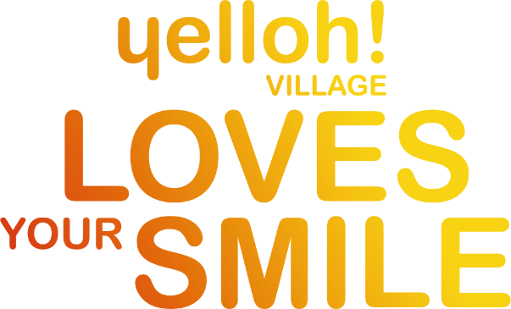
TV campaign
Devised by Blue Egg, produced by Big Production and created by Lars Blumers, the new campaign comes as a series of 3 stories, each 20 seconds in length.
With each one introducing in turn a couple, a father and daughter and two teenagers, as well as organisers, supervisors and masseurs from the Yelloh teams, the stories are light in tone and a little quirky, immersing us in "Yelloh" experiences.
The story's protagonists will be appearing on TV in France from 30th December during the series "Un si Grand Soleil" on France2, then on mainstream TV.

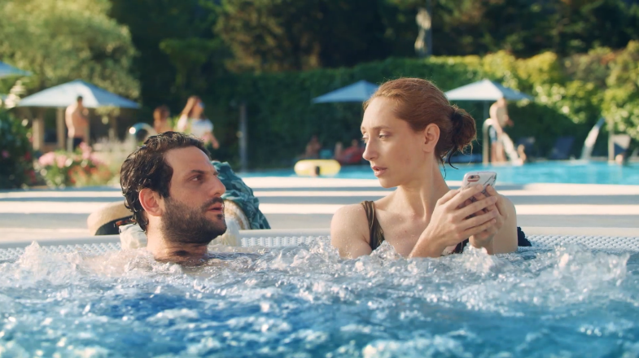
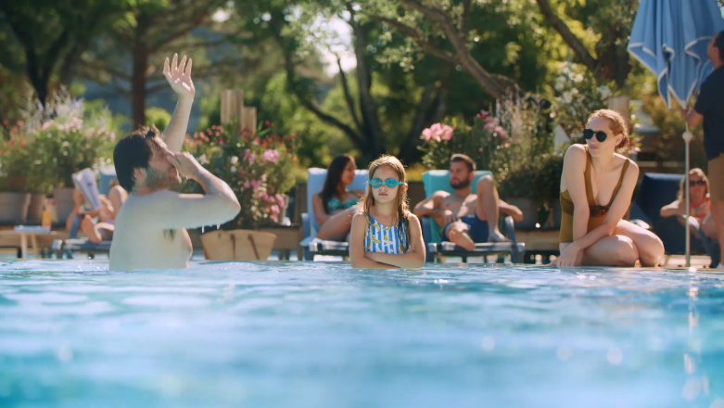
Digital campaign
A new commercial website
With new colours and a new design, the website is taking on a new look and adapting to its new pitch: fresher and more fun, its convivial tone awaits you from its homepage as a means of reflecting the Yelloh spirit and the relationship that takes shape with every holidaymaker, while always respecting the responsive design and being mindful of the user experience.
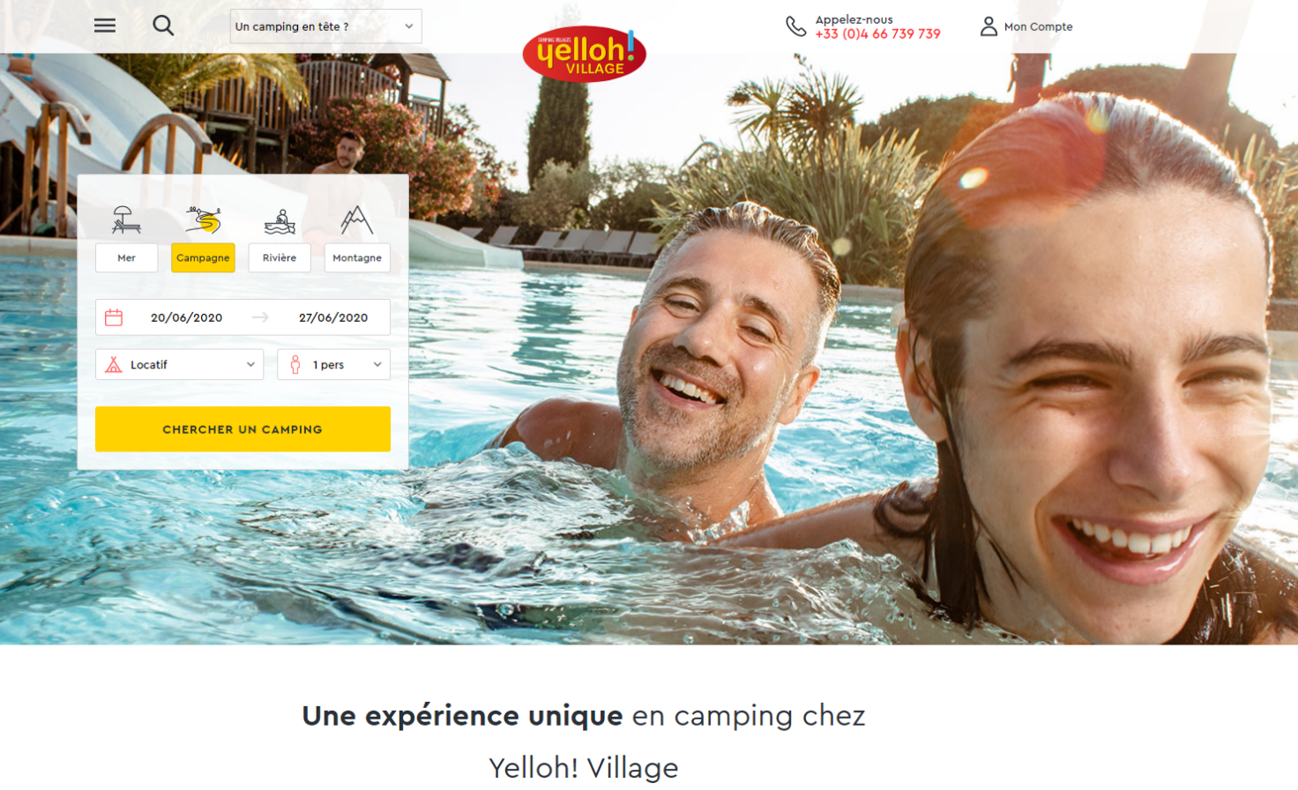
Refresh produced jointly with UX design UserAdgents agency and Kaliop
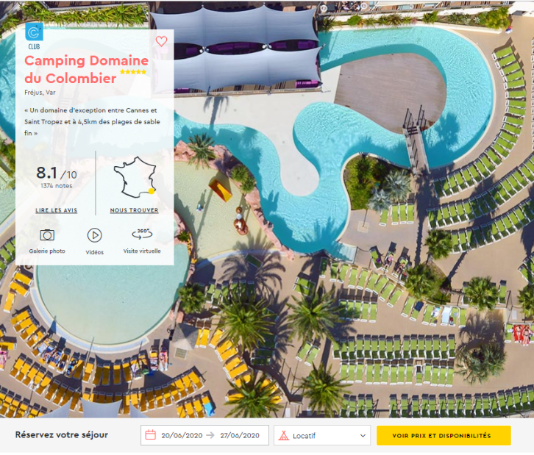
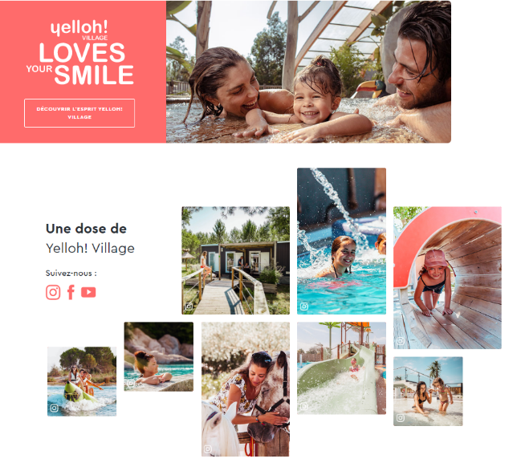
Experience the Smile on video
Video is on the rise and tells a story. A new series called "A Story of Smiles", specially for digital, has arrived. Produced in documentary format, every passion is shared with love and authenticity. These will be broadcast exclusively online and on social networks.

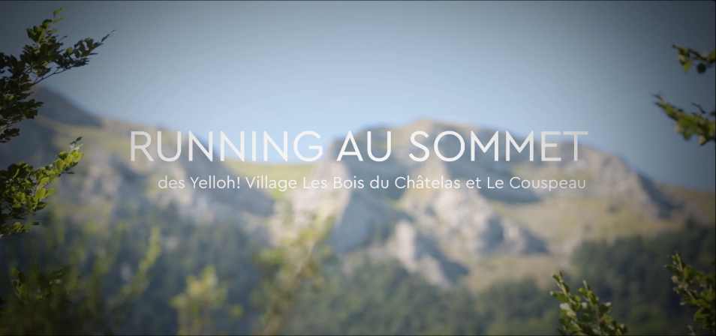
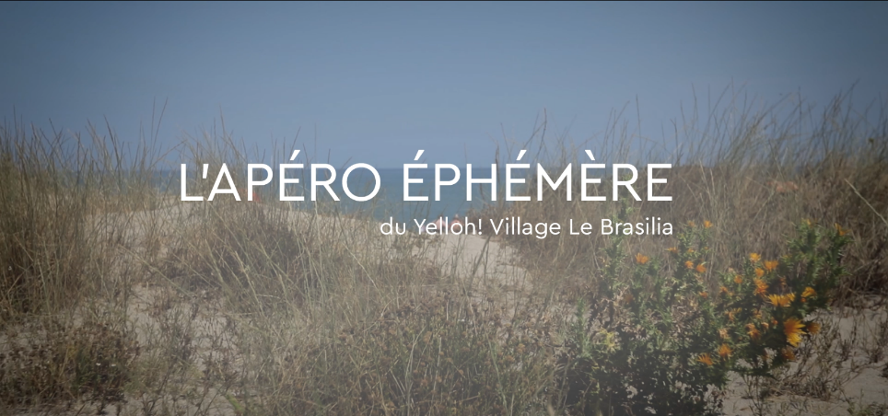
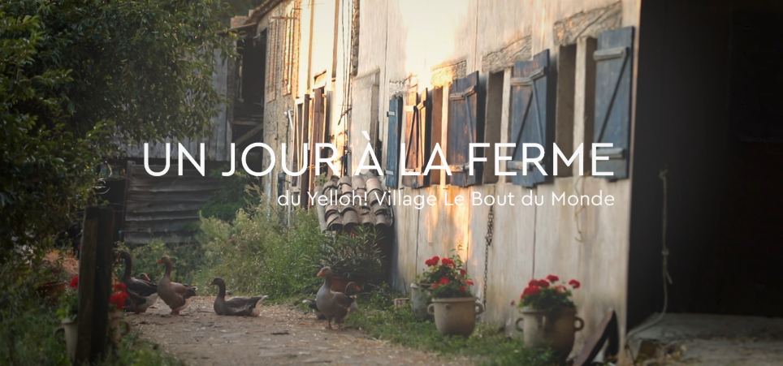
Devised by Blue Egg – Produced by Noko Production
A propos
Yelloh! Village, leading the field in upmarket campings-villages, wants to put smiles on the faces of its holidaymakers. This is why the group is providing more and more destinations in France, Spain and Portugal, meeting all your holiday desires. Today, Yelloh! Village comprises 90 campings-villages and brings together the finest open-air hotels. With ever improving levels of comfort, authenticity, entertainment options, aquatic parks, facilities and more, the quality of what we offer and the commitment of our teams towards the wellness of our customers are what drive Yelloh! Village forward.
Contacts
For all information about the Yelloh! Village group:
Bernard Sauvaire, Chairman of the Board,
bsauvaire@yellohvillage.com,
Etienne Page, Director, e.page@yellohvillage.com
Press contact: Myriam Benentendi, Marketing manager,
m.benentendi@yellohvillage.com, tel.: +33 (0) 4 66 736 306.

Further information on our website: www.yellohvillage.co.uk and on our corporate website: www.yellohvillagepro.com.

Yelloh! Village – 7 Chemin du Môle – 30220 Aigues Mortes – France
Tel. +33 (0) 466 739 739 – http://www.yellohvillage.co.uk

Yelloh! Village is the registered trademark of Europe Plein Air SAS with capital of €650 340
RCS Nîmes 432 366 839 – Registered in the register of tour and holiday operators under no. IM030110015

